Cody Williams

CSCE 465

Homework 3 Report

3.1 Task 1: Encryption using different ciphers and modes [6 pts]

Mode 1: cbc

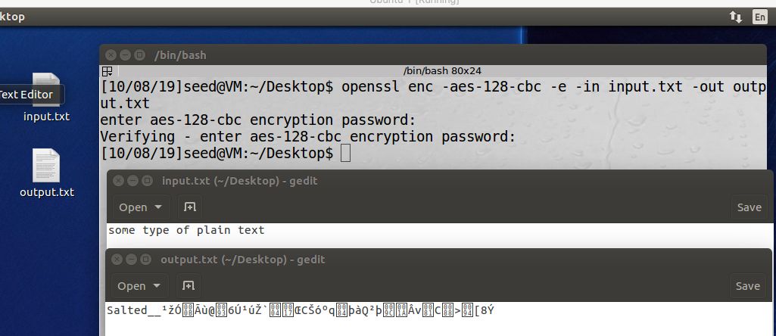 Cypher type 1: -aes-128-cbc

Mode 2: cfb

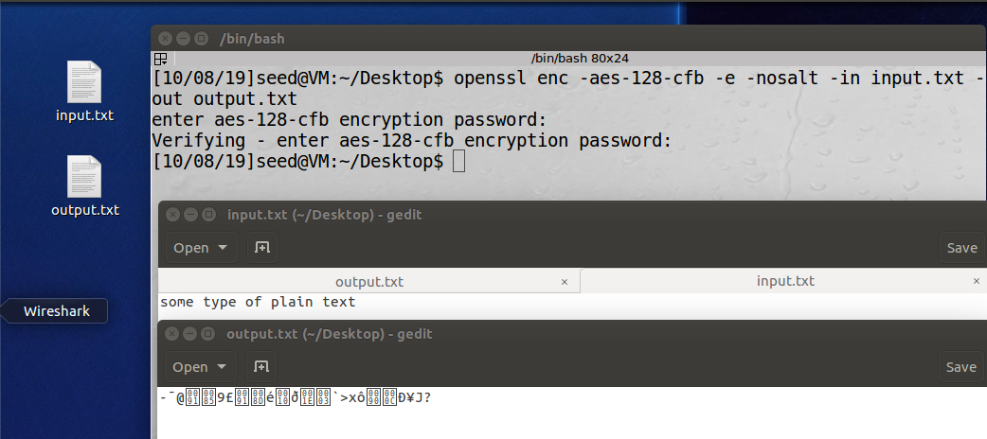 Cypher type 2: -aes-128-cfb

Mode 3: ofb

Cypher type 3: bf-ofb

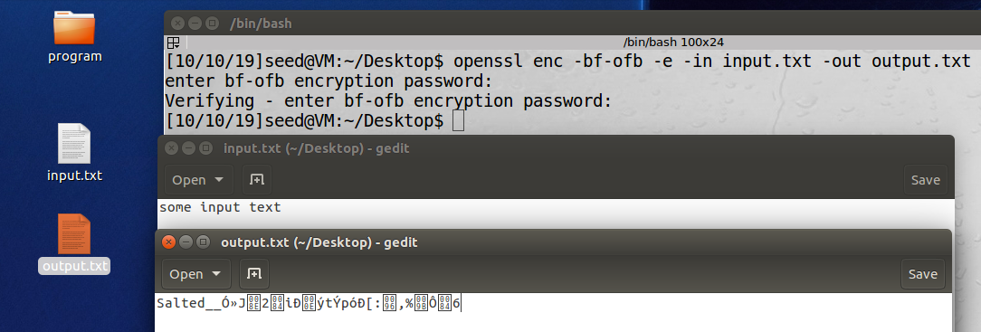

Mode 4: ecb

Cypher type 4: -des-ecb

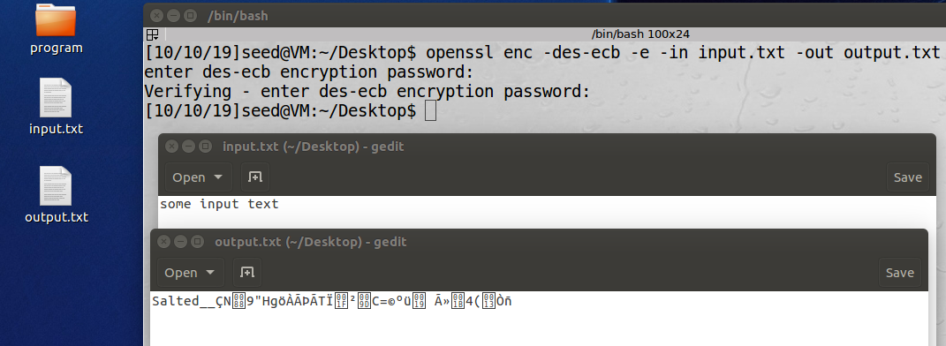

3.2 Task 2: Encryption Mode – ECB vs. CBC [8 pts]

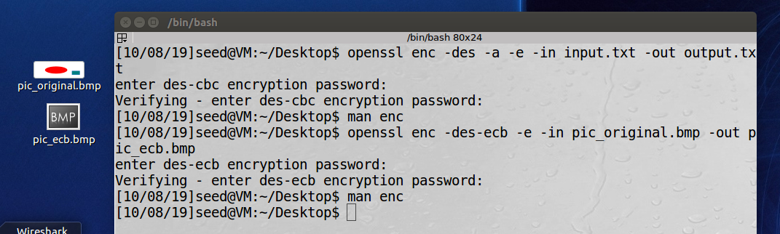Encrypting using ECB

Encrypting using CBC

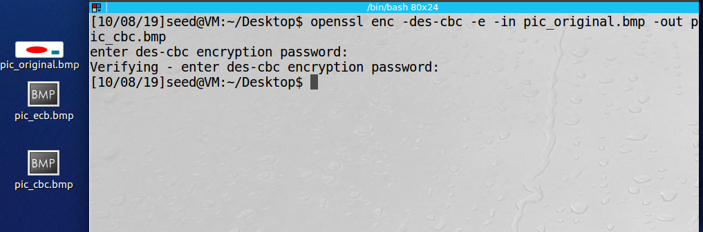

Replacing the headers for ecb encrypted bmp file:

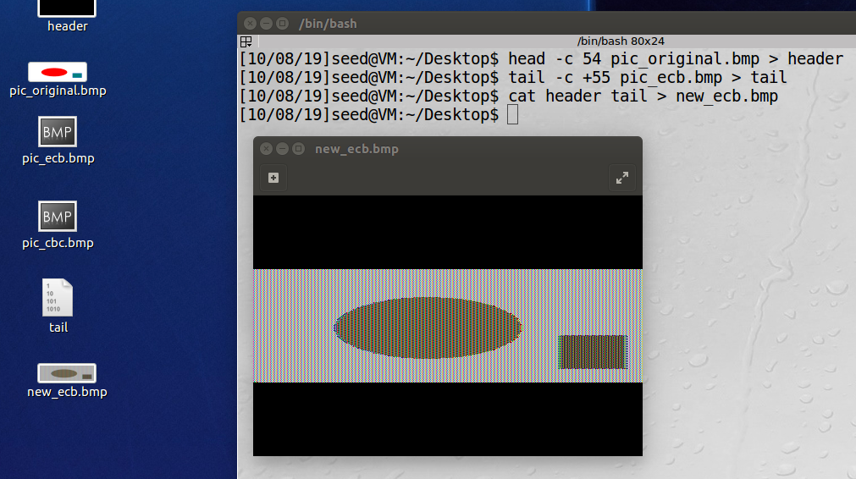After ebc encryption, the basic shapes within the image are distinguishable but the colors are not.

Replacing headers for the cbc encrypted file

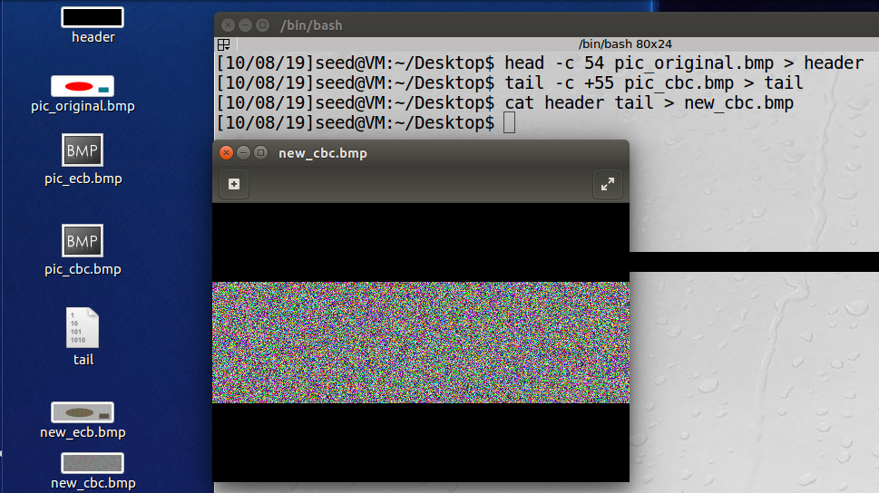After cbc encryption, there are virtually no distinguishable features of the original .bmp file.

Encrypting a picture of my choice using cbc encryption:

The encryption of my bmp image of choice appeared to have the same effect as the previous experiment. Cbc encryption of an image appears to me a much more affect method than ecb encryption.

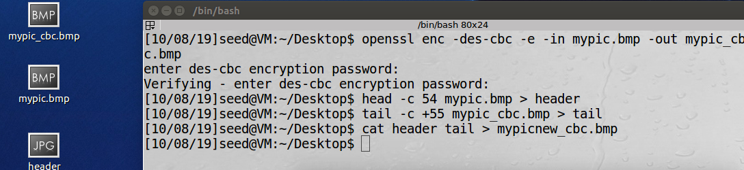

Original After encryption



3.3 Task 3: Encryption Mode – Corrupted Cipher Text [10 pts]

1. 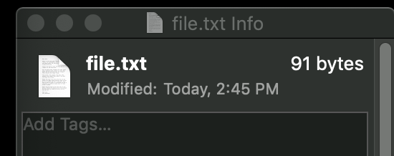Create a text file that is at least 64 bytes long.
2. Encrypt the file using the AES-128 cipher.

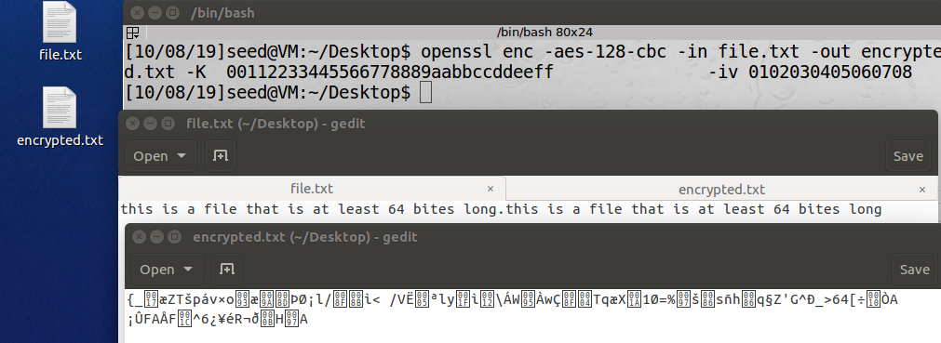

1. 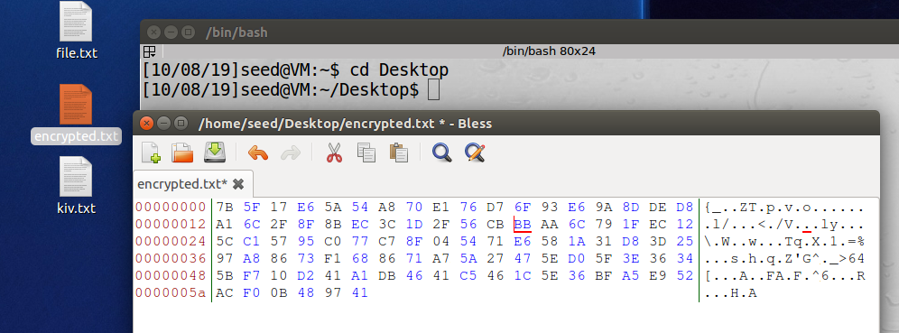Unfortunately, a single bit of the 30th byte in the encrypted file got corrupted. You can achieve this. The highlighted byte was changed from 05 to BB
2. 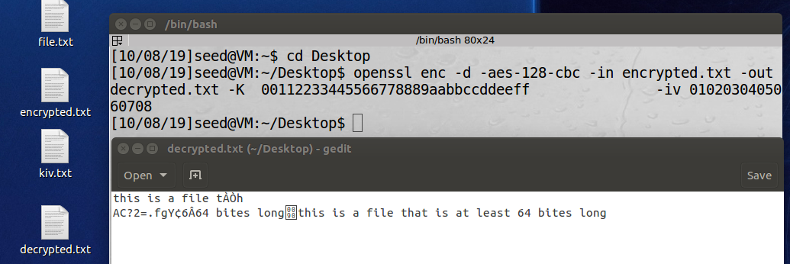Decrypt the corrupted file (encrypted) using the correct key and IV.

Answer the following questions

1. How much information can you recover by decrypting the corrupted file, if the encryption mode is ECB, CBC, CFB, or OFB, respectively? Please answer this question before you conduct this task
   1. ECB: I think that ecb will offer the greatest amount of information recovery based on the amount of information recovered in the previous task.
   2. CBC: I think that cbc will offer the lease amount of information recovered because of how this encryption method performed in the previous exercise.
   3. CFB: I think that CFB will have the second most amount of information available after corruption of the 30th byte. This is simply a guess before testing the encryption and decryption.
   4. OFB: I think OFB will have the third most information available after corruption of the 30th byte. Again, this is simply a guess before testing encryption and decryption using this method.
2. Please explain why
   1. ECB: Earlier assumption was close to correct. Most of the information was recovered with ecb encryption, only 1 block is affected
   2. CBC: This assumption was close to correct. The error in the corrupted byte affected several of the encrypted blocks, limiting the amount of information recovery
   3. CFB: This assumption was close to correct. The corruption of the 30th byte will affect a reoccurring ratio of the encrypted blocks of the text.
   4. OFB: Earlier assumption is incorrect. In OFB, only the 30th bit is corrupted making this the method allowing for most information recovery.

(3) What are the implications of these differences?

1. ECB: ECB encryption results in the creation several identical cypher blocks which can be recognizable to an attacker and also rearranged without consequence. Because of these vulnerabilities, ecb encryption should be avoided.
2. CBC: This method is one of the more secure methods because ab error in the encrypted data will propagate through several of the other encrypted blocks, and preventing the recovery of encrypted information.
3. CFB: Because an error in a single block will affect the other blocks, this is a much more secure method of encryption compared to OFB, and ECB
4. OFB: Because only an extremely limited number of bytes are affected by the corruption of the information encrypted using OFB, it should be avoided, and other methods of encryption should be used to ensure data integrity.

3.4 Task 4: Programming using the Crypto Library [15 pts]

Compiling and running the code

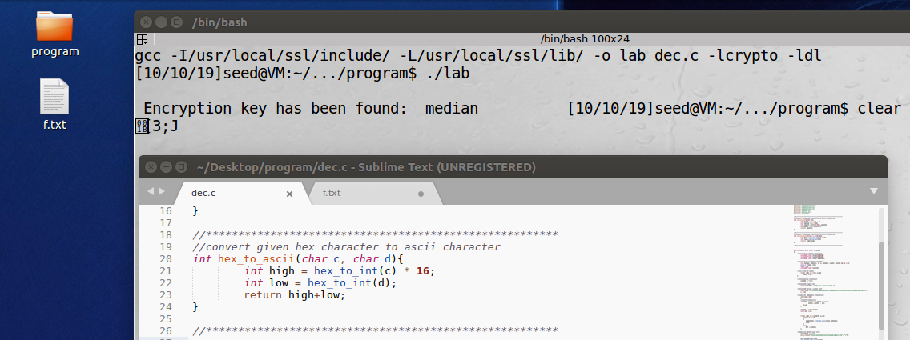

Main elements of the Code:

